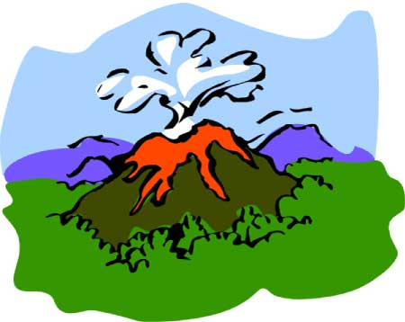
Volcanic Activity Heats Up!
Although you may not hear about it in the news, there is volcanic activity happening constantly somewhere on the planet! The Global Volcanism Program is maintained by the Smithsonian Museum of Natural History in conjunction with the United States Geological Survey. The program’s mission is to document, understand, and disseminate information about global volcanic activity. You will visit the GVP website and research the most recently active volcano. Click the link below to get started:
Global Volcanism Program
From the Home page, click the “All Weekly Activity Reports” link on the right side of the screen. This will take you to the latest update of volcanic activity. Scroll down the screen to find “New Activity/Unrest.” Choose one of the recently active volcanoes to be the subject of your research.
Your research must be written in paragraph form using complete sentences and correct grammar, spelling, and punctuation. You will want to include the following points of information and elements in your research:
  - name of volcano
  - country where the volcano is located
  - latitude and longitude of volcano
  - elevation
  - type of volcano
  - the date of the most recent activity
  - a short summary of the background of the volcano
  - a description of the most recent activity
  - a summary of the eruption history
  - a recent image of the volcano (remember to cite your image source)
Type your researched information in paragraph format using complete sentences in a Word document. If you used websites other than the GVP site provided, cite them at the end of your Word document. See the assessment rubric to find out how your research will be graded.

Directions for Submitting Your Applied Knowledge Assessment
For this Applied Knowledge Assessment, you will be submitting ONE document for credit. Save your assessment with your name included in the file extension.
For example: Earth_Science_Volcanic_Activity_research_JohnSmith
After you have saved your document, submit it to be graded for your Applied Knowledge Assessment.

